Opportunity Log
Benefits at a glance….
- All ideas for process improvement recorded in one place
- Opportunities can be prioritised to build an action plan

Design

What is it?
An opportunity log is a simple tool used to capture and track potential opportunities that arise when reviewing a process. Recording key information (as per the example below), will then help you to prioritize the ideas collected.
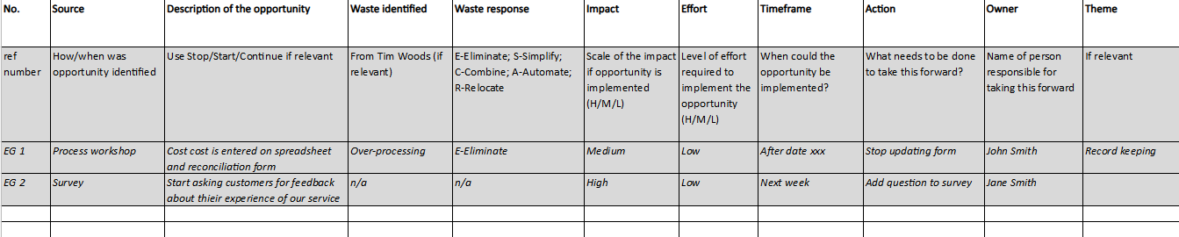Figure 1: Template

When to use it?
The Opportunity Log is a key tool when looking at ways in which your current process can be improved.

How to use it?

For each idea/change identified, complete each relevant column on the template (which includes examples and guidance notes).
See also the Impact/Effort guidance to help complete the Impact and Effort columns; and ESCAR guidance to complete that column. This information will then help you build your Action Plan.
By having a named owner for the opportunity and a timeframe this will help prioritise the order in which you tackle the items on the list.
The Theme column is also useful to help you to group similar opportunities and help the team to identify where changes should be focused.

Tips
- Process improvement is best when it includes everyone involved in the process, including the final customers. This ensures that the opportunities you identify will be an improvement for everyone and not just create a problem further along the process.
- When documenting the current state process, stakeholders can often start thinking how they want the process to be. Focus recommends using a ‘car park’ to capture these ideas so they are not lost. They can be added to the Opportunity Log so they can be considered when you start to look at improvements. Similarly, ideas raised which are not really in scope of a project or piece of work can be saved onto a log for later consideration.

